**Steps to create Function Group**

1. Go to t code se80

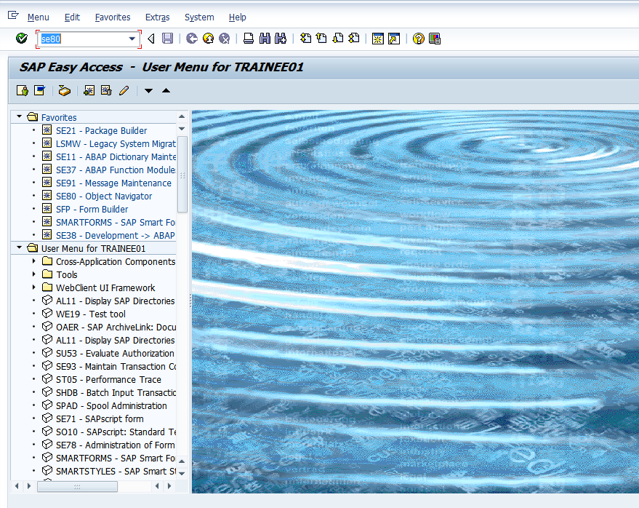

1. Choose Function Group in the object category

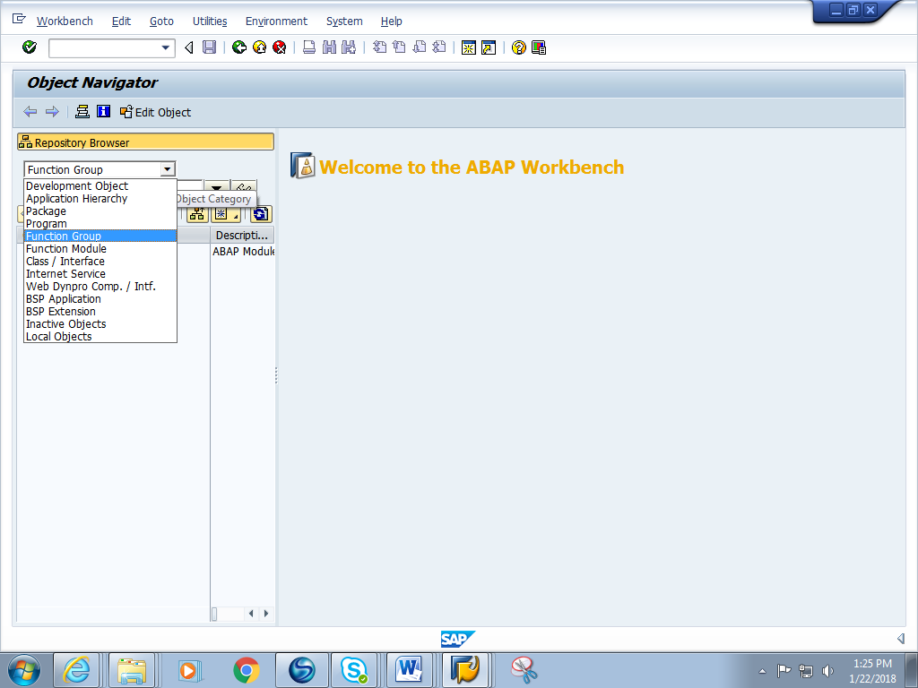

1. Give a Function Group name starting with Z or Y Eg. ZFG_RTC and press enter

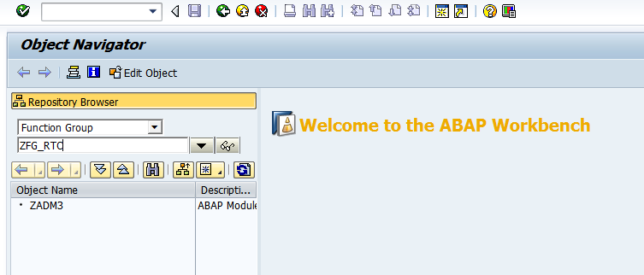

1. A pop asking if ‘Function group needs to be created’ pops up. Click on yes.

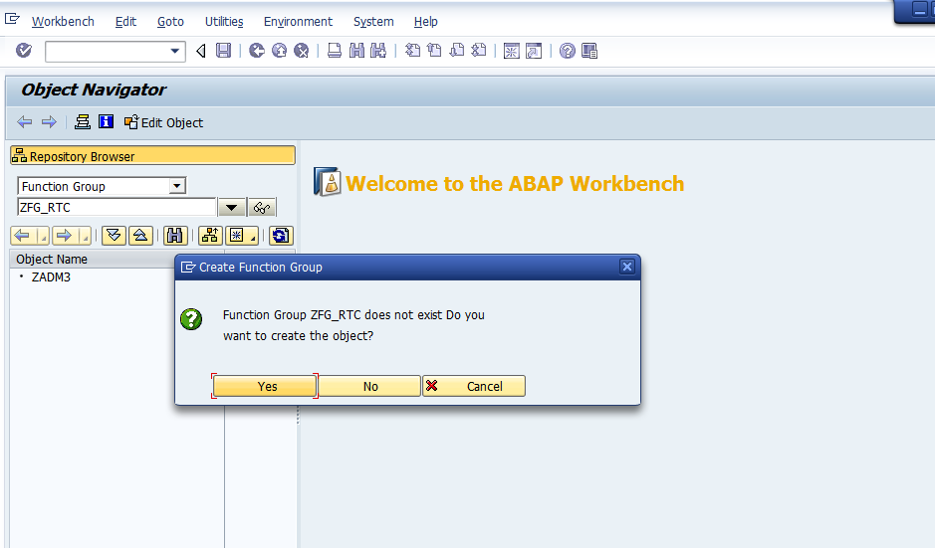

1. Give any short description and save it in a local package.

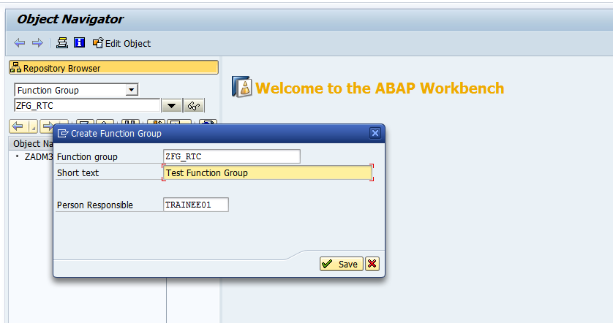

6. You will get a green message at the bottom saying ‘Function group is created’

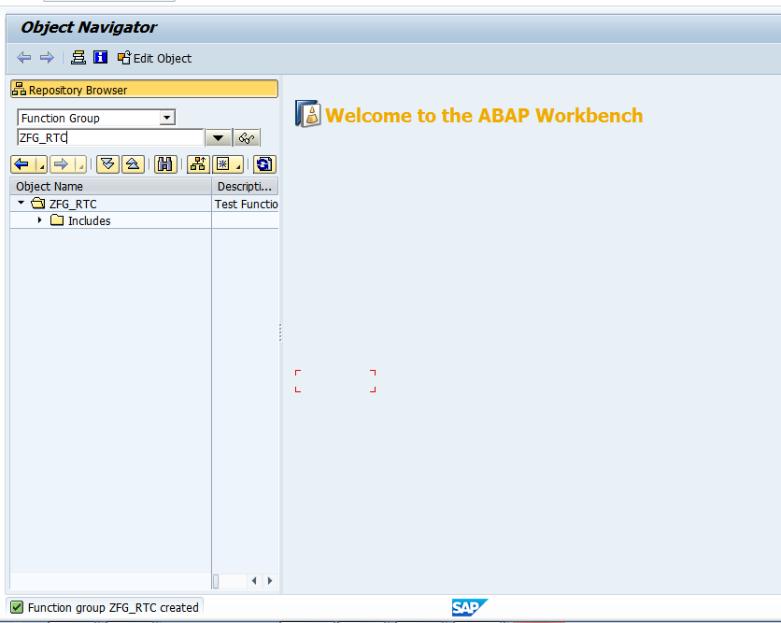

7. Right click on the name of the function group as shown .Choose activate.

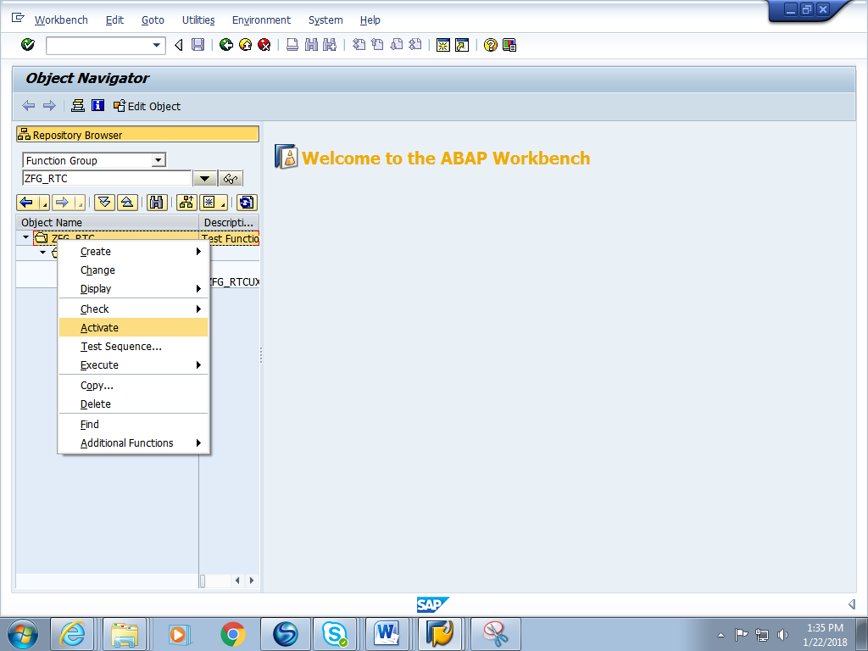

8 .The function group is activated and ready for use.

